Goat and Sheep producer:
FARMATAN is nature’s answer to scours. It’s produced naturally from Sweet Chestnut Tannin. FARMATAN can reduce the pathogen load that causes common scours including cocci in young and mature animals by protecting the lining of the gut. It has been used for many years in Europe and has had great impact in the USA over the last 7 years.
It is also very good for the mother with excellent impact on liver function and fertility, with higher antibodies in Colostrum, and improved milk production.
FARMATAN comes in powder, granular, liquid, as well as 100 and 250 pound tubs and can be included in roll mixes, pellets and cubes.
No withdrawal issues in any stage of production and heat stable to over 300 degrees Fahrenheit.
Case study: Savanna Goats, Estelline, SD.
- 152 head treated over 30 days at 5 grams/head/day. Cocci dropped 85% in 2 wks and 98% reduction in 30 days. Kids had better weight gain by weaning.
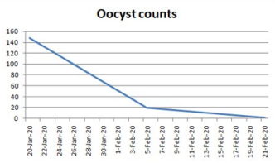 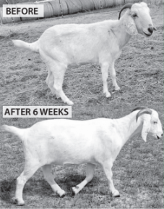
For more information go to www.FarmatanUSA.com or contact Steve Garton: 620-664-0252

